***This can possible be used as cover pictures.***



<https://www.heart.org/-/media/images/news/2019/january-2019/0131statupdate_sc.jpg?la=en&hash=0E8CE18B259DE91547F67B2C5721F3CCAAD78345>

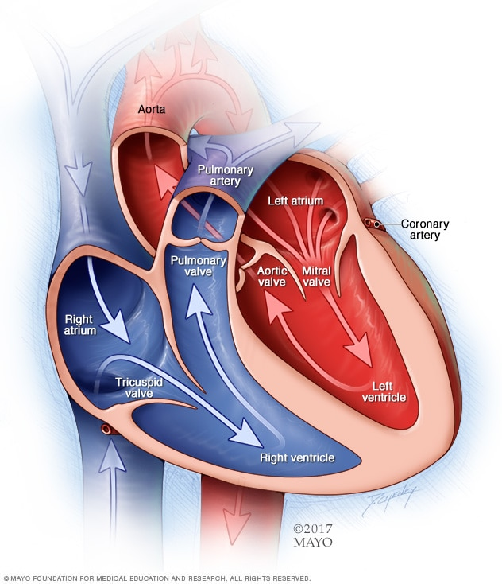

<https://www.mayoclinic.org/diseases-conditions/heart-disease/symptoms-causes/syc-20353118>

***(This information is obtained from the mayo clinic)***

Heart disease describes a range of conditions that affect your heart. Diseases under the heart disease umbrella include blood vessel diseases, such as coronary artery disease; heart rhythm problems (arrhythmias); and heart defects you're born with (congenital heart defects), among others.

The term "heart disease" is often used interchangeably with the term "cardiovascular disease." Cardiovascular disease generally refers to conditions that involve narrowed or blocked blood vessels that can lead to a heart attack, chest pain (angina) or stroke. Other heart conditions, such as those that affect your heart's muscle, valves or rhythm, also are considered forms of heart disease.

Many forms of heart disease can be prevented or treated with healthy lifestyle choices.

**Cardiovascular disease** generally refers to conditions that involve narrowed or blocked blood vessels that can lead to a **heart attack**, chest pain (angina) or stroke. Other **heart** conditions, such as those that affect your **heart's** muscle, valves or rhythm, also are considered forms of **heart disease**.

***(American Heart Association)***

<https://www.heart.org/en/health-topics/consumer-healthcare/what-is-cardiovascular-disease/coronary-artery-disease>

Coronary heart disease is a common term for the [buildup of plaque](https://www.heart.org/en/health-topics/cholesterol/about-cholesterol/atherosclerosis) in the heart’s arteries that could lead to heart attack. But what about coronary artery disease? Is there a difference?

The short answer is often no — health professionals frequently use the terms interchangeably.

However, coronary heart disease , or CHD, is actually a result of coronary artery disease, or CAD, said Edward A. Fisher, M.D., Ph.D., M.P.H., an American Heart Association volunteer who is the Leon H. Charney Professor of Cardiovascular Medicine and also of the Marc and Ruti Bell Vascular Biology and Disease Program at the NYU School of Medicine.

With coronary artery disease, plaque first grows within the walls of the coronary arteries until the blood flow to the heart’s muscle is limited. [View an illustration of coronary arteries](http://watchlearnlive.heart.org/CVML_Player.php?moduleSelect=corart). This is also called [ischemia](https://www.heart.org/en/health-topics/heart-attack/about-heart-attacks/silent-ischemia-and-ischemic-heart-disease). It may be chronic, narrowing of the coronary artery over time and limiting of the blood supply to part of the muscle. Or it can be acute, resulting from a sudden rupture of a plaque and formation of a thrombus or blood clot.

The traditional risk factors for coronary artery disease are high [LDL cholesterol](https://www.heart.org/en/health-topics/cholesterol/hdl-good-ldl-bad-cholesterol-and-triglycerides), low [HDL cholesterol](https://www.heart.org/en/health-topics/cholesterol/hdl-good-ldl-bad-cholesterol-and-triglycerides), [high blood pressure](https://www.heart.org/en/health-topics/high-blood-pressure), family history, [diabetes](https://www.heart.org/en/health-topics/diabetes), [smoking](https://www.heart.org/en/healthy-living/healthy-lifestyle/quit-smoking-tobacco), being post-menopausal for women and being older than 45 for men, according to Fisher. Obesity may also be a risk factor.

“Coronary artery disease begins in childhood, so that by the teenage years, there is evidence that plaques that will stay with us for life are formed in most people,” said Fisher, who is former editor of the American Heart Association journal, ATVB. “Preventive measures instituted early are thought to have greater lifetime benefits. [Healthy lifestyles](https://www.heart.org/en/health-topics/cholesterol/prevention-and-treatment-of-high-cholesterol-hyperlipidemia) will delay the progression of CAD, and there is hope that CAD can be regressed before it causes CHD.”

Living a healthy lifestyle that incorporates [good nutrition](https://www.heart.org/en/healthy-living/healthy-eating), [weight management](https://www.heart.org/en/healthy-living/healthy-eating/losing-weight) and getting plenty of [physical activity](https://www.heart.org/en/healthy-living/fitness) can play a big role in avoiding CAD.

“Coronary artery disease is preventable,” agreed Johnny Lee, M.D., president of New York Heart Associates, and an American Heart Association volunteer. “Typical warning signs are [chest pain](https://www.heart.org/en/health-topics/heart-attack/angina-chest-pain), shortness of breath, palpitations and even fatigue.”

If you feel any of these symptoms, don’t delay — call 9-1-1

Possible Design for Powerpoint Presentation.

